Decision Tree Algorithm
- Decision Tree is supervised Machine learning algorithm use to slove classification problems.
- The goal is to create model that predicts the value of target variable by learning simple decision rule from data feature.
- It learn from the conditional concepts like decision rules.
- Every decision rules has some conditions.
- The dipper the tree more complex the decision rule and fitter the model.
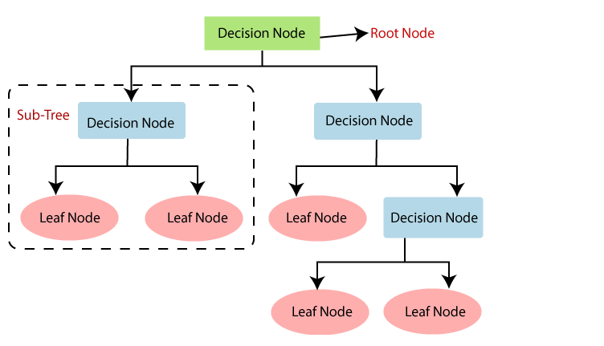

ASM Technique (Attribute Selection Measure)
- While implementing decision tree the main issue arise that how to select the best attribute for the root node and for subnodes.
- To slove such problem there is an technique we call (ASM).
- There are two types:
  - Information gain
  - Gini Index

Advantages of Decision Tree
- A decision tree does not require scaling of data as well.
- Decision tree does not require normalization of data.

Disadvantages of Decision Tree
- A small change in data can cause a large change in the structure of the decision tree causing instability.

Applications of Decision Tree
- Marketing
- Detection of frauds

